Penetration Test Report for

<Insert Company>

<insert company logo>

<insert date>

Engagement & Report Authored By:

Restricted

# **Table of Contents**

**1 Document Control…………………………………………………….**

1.1 Proprietary Information.…………..………………………………………

**2. Executive Summary………………………………………………….**

2.1 Scope of Work………………………………………………………………….

2.2 Project Objectives………………………………………………………….…

2.3 Timeline…………………………………………………………………………….

2.4 Risk Ratings..……………………………………………………………………

2.5 High-Level Summary of Findings…………………………………….

2.5a OWASP Top 10 Results…………………………………………..

2.7 Summary of Recommendations……………………………………….

**3. Methodology……………………………………………………………**

3.1 Planning…………………………………………………………………………….

3.2 Exploitation………………………………………………………………………

3.3 Reporting………………………………………………………………………….

**4. Technical Findings…………………………………………………..**

4.1 Detailed Systems Information………………………………………..

4.2 Tools Used………………………………………………………………………..

4.3 Vulnerability Analysis………………………………………………..

**5. Technical Methodology…………………………………………….**

5.1………………………………………………………………………………………….

5.2………………………………………………………………………………………….

5.3………………………………………………………………………………………….

# **1. Document Control**

| Title |  |
| --- | --- |
| Version |  |
| Author |  |
| Pen-Testers |  |
| Approved By |  |
| Classification | **Restricted** |

## Version Control

| Version | Date | Issued By | Description |
| --- | --- | --- | --- |
|  |  |  |  |

## 1.1 Propietary Information

The content of this document is considered proprietary information and is classified as RESTRICTED. Therefore, it should not be disclosed to anyone outside of this level of clearance.

Permission is given to copy this report for the purposes of disseminating information within <company name>’s C-suite and authorized individuals.

## 

# **2. Executive Summary**

A security assessment and penetration testing are conducted against in-scope domains of the <company name and their product>. The assessment provides insight into the resilience of the application to withstand attacks from unauthorized users and the potential for valid users to abuse their privileges and access.

This current report details the scope of testing conducted, all significant findings, and detailed remedial advice. Vulnerabilities mentioned in this report are listed in order of severity (using [CVSS](https://en.wikipedia.org/wiki/Common_Vulnerability_Scoring_System)) and order of exploitation. The summary below provides a non-technical audience with a summary of the key findings. The fourth section of this report relates the key findings and contains technical details of each vulnerability that was discovered during the assessment along with tailored best practices to fix. Finally, the fifth section provides step-by-step instructions for a technical audience on how the test was performed.

## 2.1 Scope of Work

This security assessment covers the remote penetration testing of 1 accessible <target name> hosted on the <company ip> address. The assessment was carried out from a black box perspective, with the only supplied information being the tested <target name>’s IP address. No other information was assumed at the start of the assessment.

## 2.2 Project Objectives

The purpose of the engagement was to utilize active exploitation techniques to evaluate the security of the application against best practice criteria, validate its security mechanisms, and identify possible threats and vulnerabilities. The vulnerabilities are assigned a risk rating based on threat, vulnerability, and impact.

## 2.3 Timeline

The timeline of the engagement is as follows:

| Penetration Test | Start Time/Date | End Time/Date |
| --- | --- | --- |
|  |  |  |

## 2.4 Risk Ratings

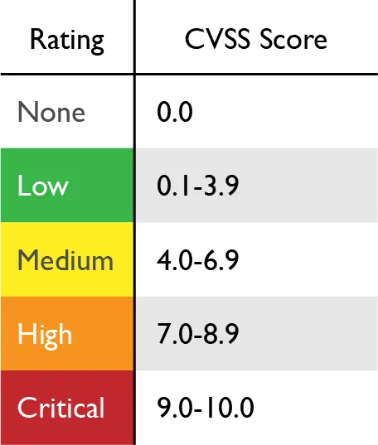

CVSS Rating Table

## 2.5 High-Level Summary of Findings

| Value | Number of Risks |
| --- | --- |
| LOW | 0 |
| MEDIUM | 2 |
| HIGH | 2 |
| CRITICAL | 3 |

Total Risk Rating

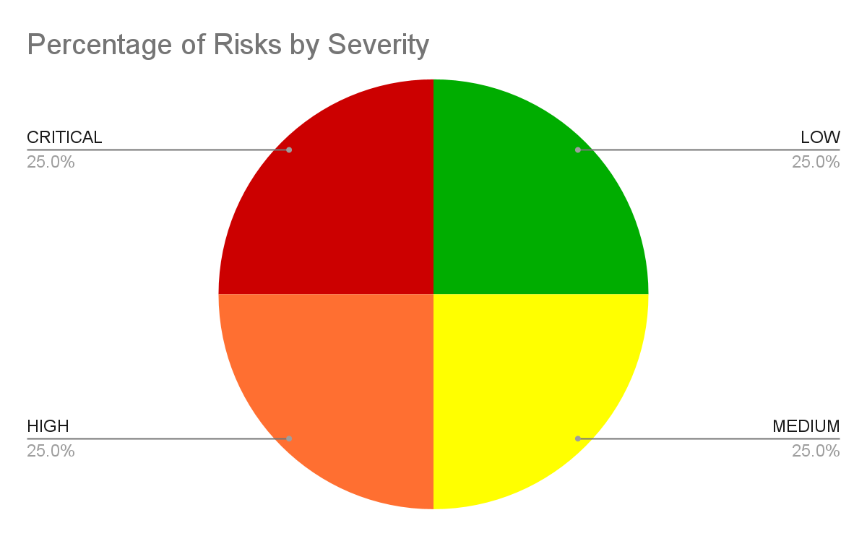

All Risks Percentage

## 2.5b OWASP Top 10 Results

Open Web Application Security Project (OWASP) is an industry initiative for web application security. OWASP has identified the 1​0 most common attacks that succeed against web applications. These comprise the OWASP Top 10.

The following table describes the status of applicable Top 10 OWASP threats

| Criteria Label | Status |
| --- | --- |
| [**A01:2021-Broken Access Control**](https://owasp.org/Top10/A01_2021-Broken_Access_Control/) |  |
| [**A02:2021-Cryptographic Failures**](https://owasp.org/Top10/A02_2021-Cryptographic_Failures/) |  |
| [**A03:2021-Injection**](https://owasp.org/Top10/A03_2021-Injection/) |  |
| [**A04:2021-Insecure Design**](https://owasp.org/Top10/A04_2021-Insecure_Design/) |  |
| [**A05:2021-Security Misconfiguration**](https://owasp.org/Top10/A05_2021-Security_Misconfiguration/) |  |
| [**A06:2021-Vulnerable and Outdated Components**](https://owasp.org/Top10/A06_2021-Vulnerable_and_Outdated_Components/) |  |
| [**A07:2021-Identification and Authentication Failures**](https://owasp.org/Top10/A07_2021-Identification_and_Authentication_Failures/) |  |
| [**A08:2021-Software and Data Integrity Failures**](https://owasp.org/Top10/A08_2021-Software_and_Data_Integrity_Failures/) |  |
| [**A09:2021-Security Logging and Monitoring Failures**](https://owasp.org/Top10/A09_2021-Security_Logging_and_Monitoring_Failures/) |  |
| [**A10:2021-Server-Side Request Forgery**](https://owasp.org/Top10/A10_2021-Server-Side_Request_Forgery_%28SSRF%29/) |  |

* *Fail,* denotes that the application is vulnerable to this kind of threat and is exploitable. *Pass,* reflects that the web app managed to defend and mitigate this threat. *N/A* denotes this threat was not able to be tested during the engagement.

<Description of current security posture along with summary of vulnerabilities found>

## 2.6 Summary of Recommendations

<Summary goes here>

# 3. Methodology

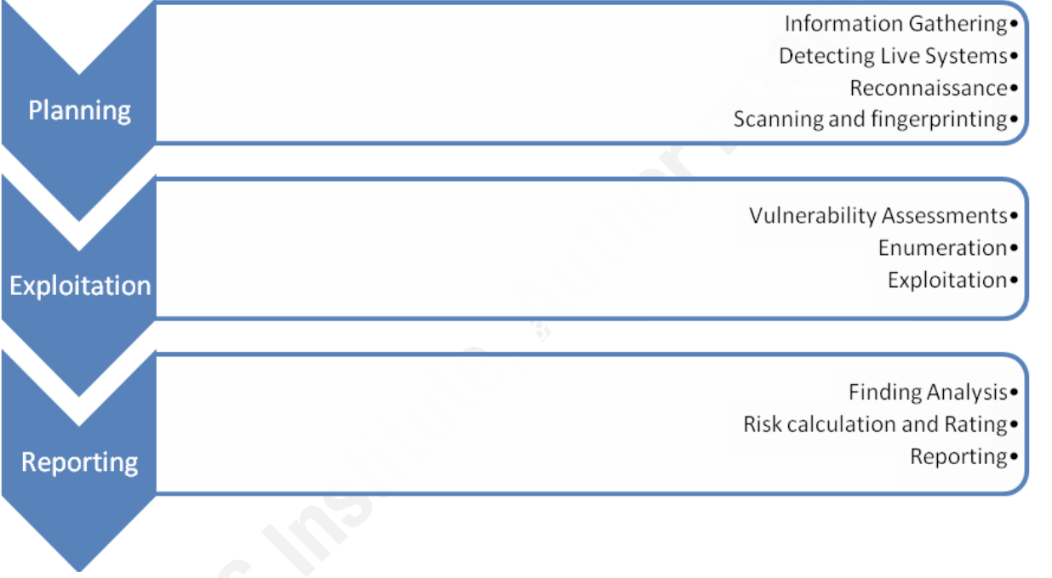Simplified version of the Penetration Testing Execution Standard

## 3.1 Planning

During the planning phase of the penetration test, we run scans to detect live hosts, their running services, operating systems, and service versions. We compile this information and use it to research any vulnerabilities in these versions of software.

## 3.2 Exploitation

The information from the Planning phase is reviewed for vulnerabilities and related exploits which can be used to test the vulnerability. We utilize only exploits that are not destructive or abusive in nature as outlined in the agreement. Exploits are attempted and raw results are recorded.

## 3.3 Reporting

Based on the findings in the Exploitation phase we analyze the results as a whole. We then use the results to calculate and rate the risk to the organization as well as recommendations on how to minimize that risk to an acceptable threshold.

Below is an illustration for a more in-depth calculation of risk and business impact than the CVSS chart. The calculation for risk is as follows

Risk=Threat * Vulnerability * Impact

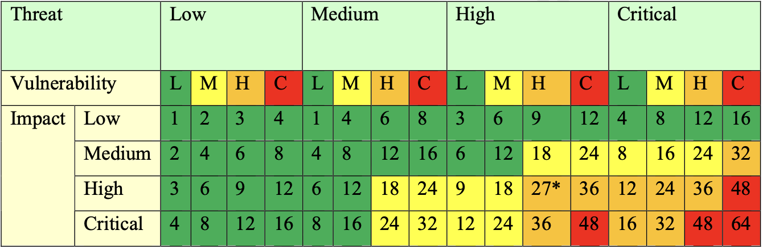

Risk Analysis Table

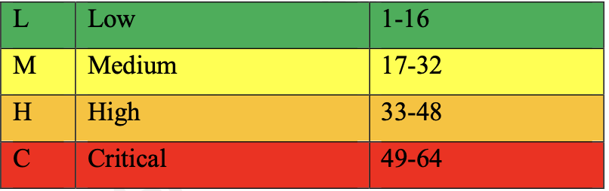

Rating Calculation

After calculating the risk rating, we start writing a report on each risk and how to properly mitigate it.

# 4. Technical Findings

The following section is intended for a technical audience such as the CISO for Bulldog Industries or individuals working in the IT department with restricted level clearance. The threats listed below will be reported based on severity, with the most severe mentioned first.

## 

## 4.1 Detailed Systems information

| IP Address | System Type | OS Information/ Web Server Info | Open Ports | | |
| --- | --- | --- | --- | --- | --- |
| Port # | Protocol | Service Name |
| 10.0.2.5 | Web-server | Ubuntu 18.04 LTS  Nginx/1.14.0 (Ubuntu) | 80 | TCP | HTTP |

Table of Target’s Open Ports

## 4.2 Tools Used

The following describes the tools used in the engagement:

| Name | Purpose |
| --- | --- |
|  |  |
|  |  |
|  |  |
|  |  |
|  |  |
|  |  |
|  |  |

## 4.3 Vulnerability Analysis

**<insert vulnerability name/description>**

**Threat Level**

<threat level>

**Vulnerability**

<vulnerability level>

**Impact**

<impact level>

**Risk Rating**

<Risk rating>

**Proof of Vulnerability**

<screenshots of vulnerability>

**Analysis**

<analysis>

**Technical Recommendations**

<recommendations>

**Lack of Sanitization/Input Validation**

**Threat Level**

High

**Vulnerability**

Critical

**Impact**

Critical

**Risk Rating**

Critical

**Proof of Vulnerability**

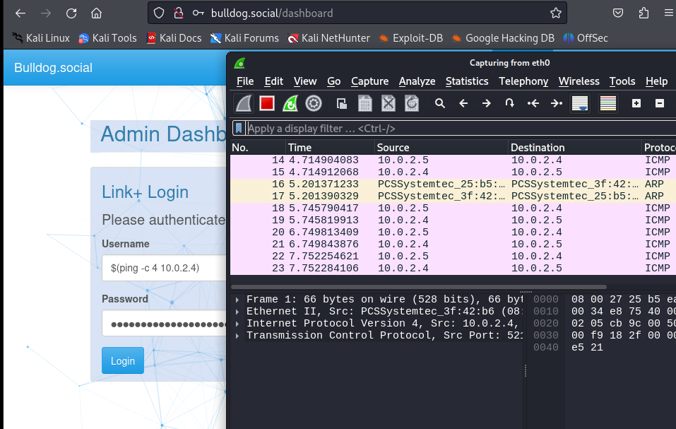

Ping Command Injection Successful

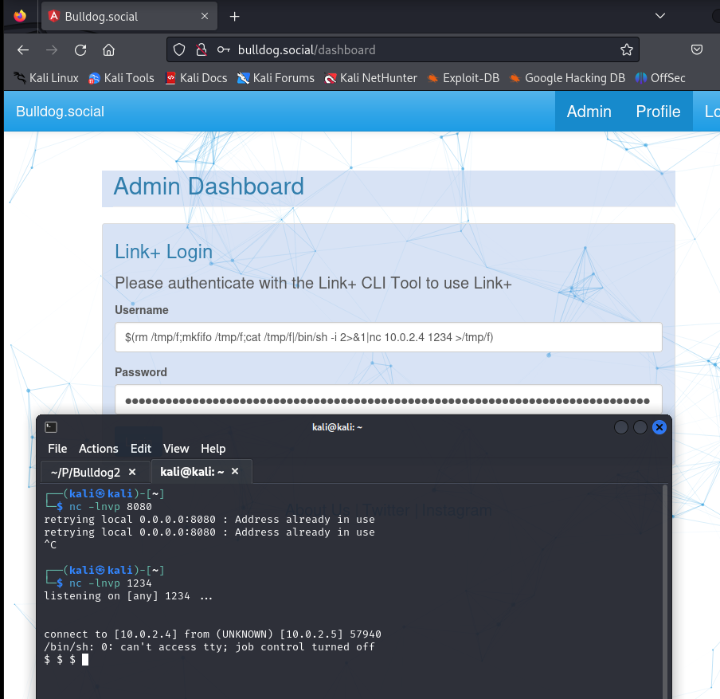

Command Injection for Reverse Shell success

**Analysis**

The dashboard gives us a hint on how authentication works. Because “CLI tool” is specified, we know the dashboard will probably have functions that work with shell commands. The only way to prove this theory was to try out some shell commands. The first command I tried was a simple ping command to see if we get an echo request/ICMP packet from the server. I input the command in both the username and password fields and fire up Wireshark to validate whether we get ICMPs from the web server. Looking at the screenshots above, we do. My hypothesis was correct and now we can start injecting malicious commands and see if we can get a reverse shell. A simple Google search for generating reverse shells with bash commands we come up with a command we can use. Setting up a Netcat listener on my host machine and I successfully get a reverse shell from the shell. The business impact of this exploit is critical. Given how easy it is to get to the admin dashboard, this vector becomes more dangerous as many threat actors can potentially exploit this vulnerability to gain a shell and start their lateral movement or action on objectives.

**Technical Recommendations**

We urge bulldog industries to find another method of authentication and to explore more in-depth PAM (privileged access management) solutions to prevent such a breach. If it is absolutely necessary to use the CLI as part of the authentication process, it is recommended to set up a different server specifically for this kind of authentication segmented away from BullDog Industries’ other assets. In this specific instance, an external DMZ could be sufficient as the server would sit in between two firewalls; one facing the internet and the other facing the internal network. Also, an IPS for the server would help analyze incoming requests and prevent a breach attempt.

**Broken Access Control in the Home Page**

**Threat Level**

High

**Vulnerability**

Critical

**Impact**

Critical

**Risk Rating**

Critical

**Proof of Vulnerability**

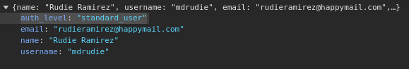

Default Authorization Level for User

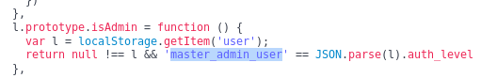

Master_admin_user function found

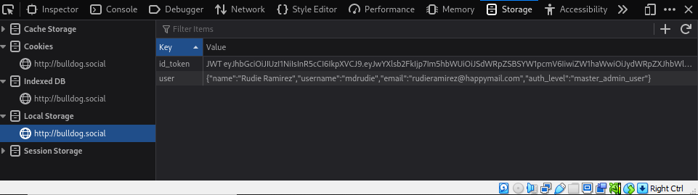

Modifying Auth Level with Web Developer Tools

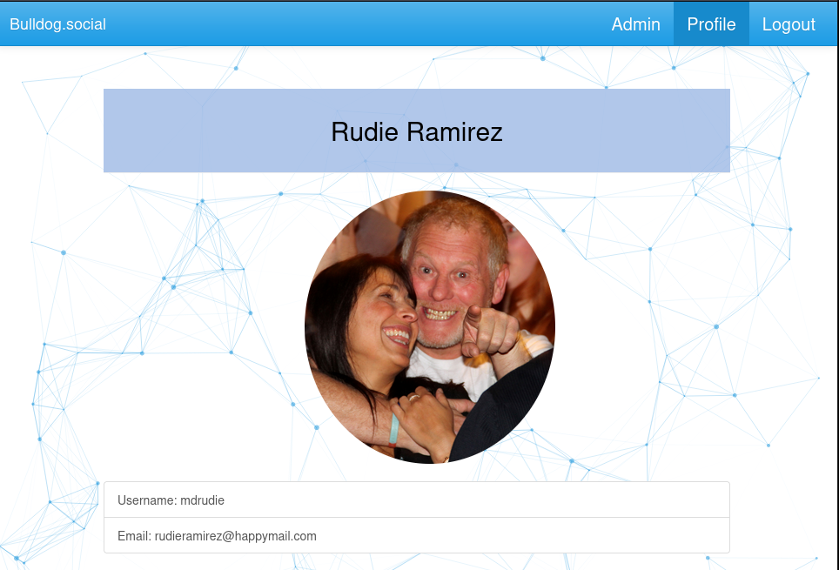

Admin dashboard becomes accessible

**Analysis**

Once logged in with user credentials, we were able to elevate our privileges within the site. We did this by looking at the source code for the site. Though the JavaScript seems to be obfuscated, by using JS beautifier tools online, a function describing a ‘master_admin_user’ gives us a big hint on how to progress. We then shift over to our web developer tools and simply change the auth_level element to ‘master_admin_user’. This change gives us access to the admin tab where we move onto the admin login. This vulnerability is number one on OWASP Top 10. The implications of this vulnerability are significant as it becomes a vector to other exploits reported.

**Technical Recommendations**

It is strongly suggested to discuss this vulnerability with Bulldog Industries’ DevSecOps department. Mitigating this involves developing safe and secure coding practices. Testing source code via static analysis and dynamic analysis tests are recommended every time prior to releasing an update to the site. Vulnerability Scanners like Nessus can also detect these vulnerabilities and are suggested to be performed at least once a month outside of business hours to minimize an impact on business operations.

**Lack of TLS/SSL Encryption**

**Threat Level**

High

**Vulnerability**

Medium

**Impact**

High

**Risk Rating**

Medium

**Proof of Vulnerability**

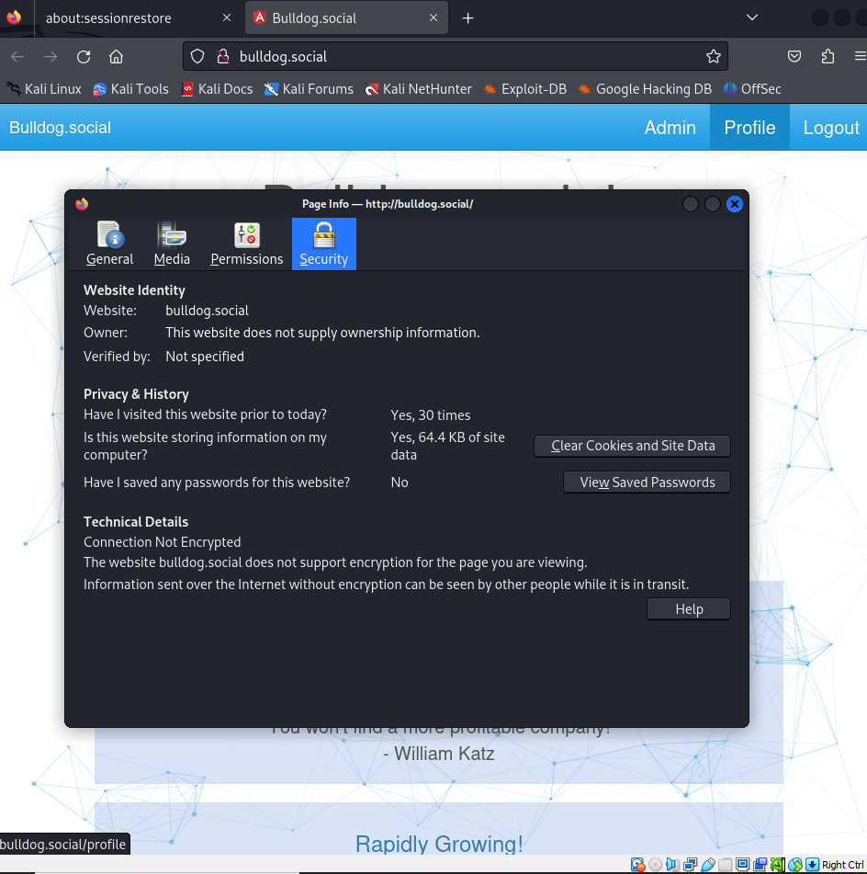

**Analysis**

Services running on port 80 are notorious for lacking any form of encryption such as TLS. This is a potentially dangerous vulnerability as anyone on the network could use a promiscuous packet sniffer device to capture login credentials for users in plaintext.

**Technical Recommendations**

Bulldog Industries should prioritize obtaining a digital certificate from a trusted Certificate Authority (CA) to secure their website with TLS encryption. This will mitigate the risk of sensitive information, such as login credentials, being exposed over unsecured connections. By implementing HTTPS (HTTP over TLS) on their web server, they will ensure that all data transmitted between the user and the server is encrypted, preventing interception by malicious actors. Additionally, using a digital certificate enhances the site’s credibility and increases user trust by providing a secure browsing experience.

**Lack of Password Policy**

**Threat Level**

High

**Vulnerability**

High

**Impact**

Critical

**Risk Rating**

High

**Proof of Vulnerability**

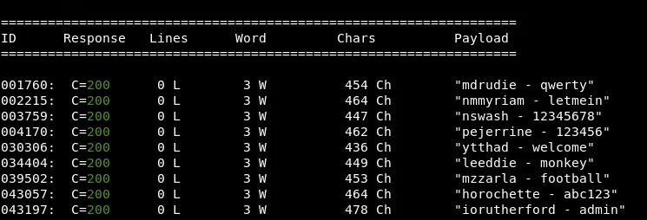

Full List of Compromised Credentials in Normal Output.

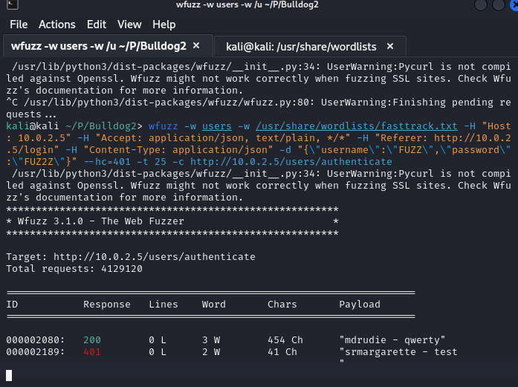

Compromised credentials for ‘mdrudie’ within 10 minutes

**Analysis**

A significant amount of users have very weak passwords that show up on popular wordlists. With their usernames already exposed, all we had to do was curl the usernames on the website of all users into a username.txt file and run the wfuzz tool to brute force their credentials. A total of 9 accounts were compromised this way, from just using one wordlist. The business impact is critical, as a significant number of users could potentially have their accounts breached from brute force attacks alone.

**Technical Recommendations**

A minimum acceptable password policy is strongly advised to thwart successful brute force attacks that pretty much any kind of threat actor can perform. In the case that credentials are compromised anyway, multi-factor authentication can be a valuable compensating control ensuring that the account isn’t breached, giving the victim time to contact the IT department and reset their password.

**Out-of-Date Operating System and Web Server**

**Threat Level**

Medium

**Vulnerability**

High

**Impact**

High

**Risk Rating**

Medium

**Proof of Vulnerability**

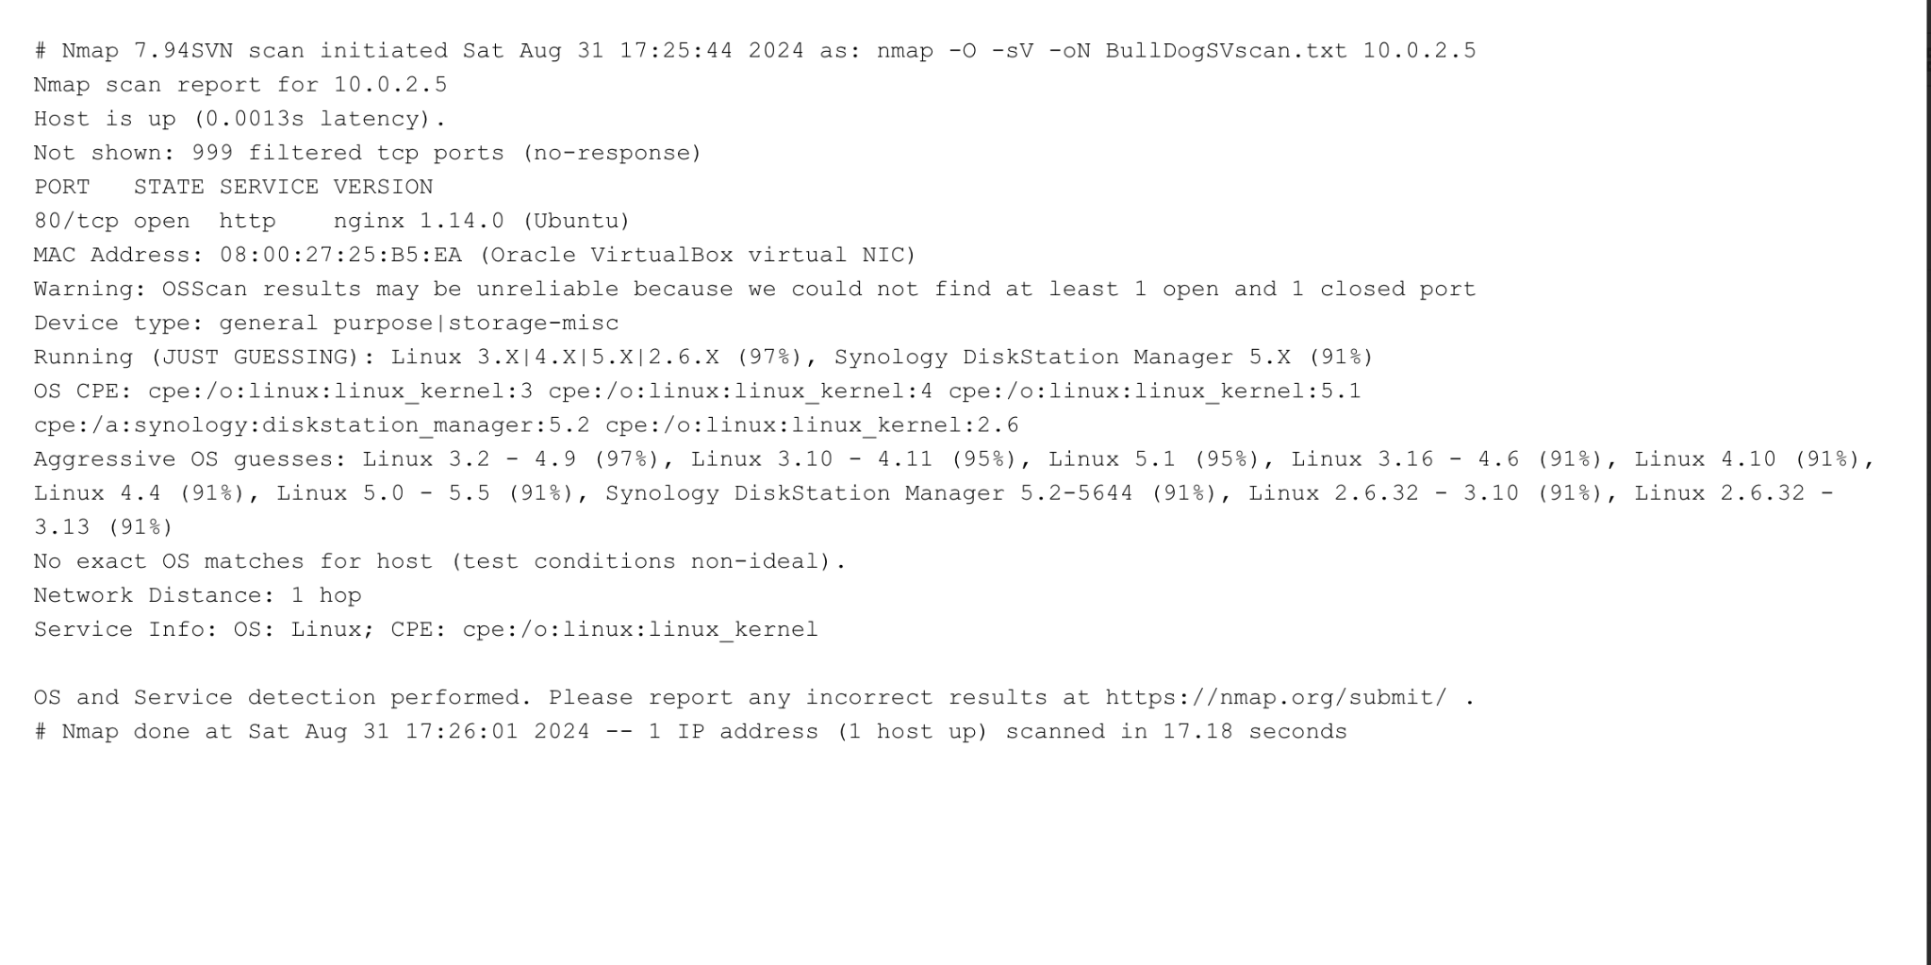

Outdated Webserver Version (nginx 1.14.0) Nmap scan

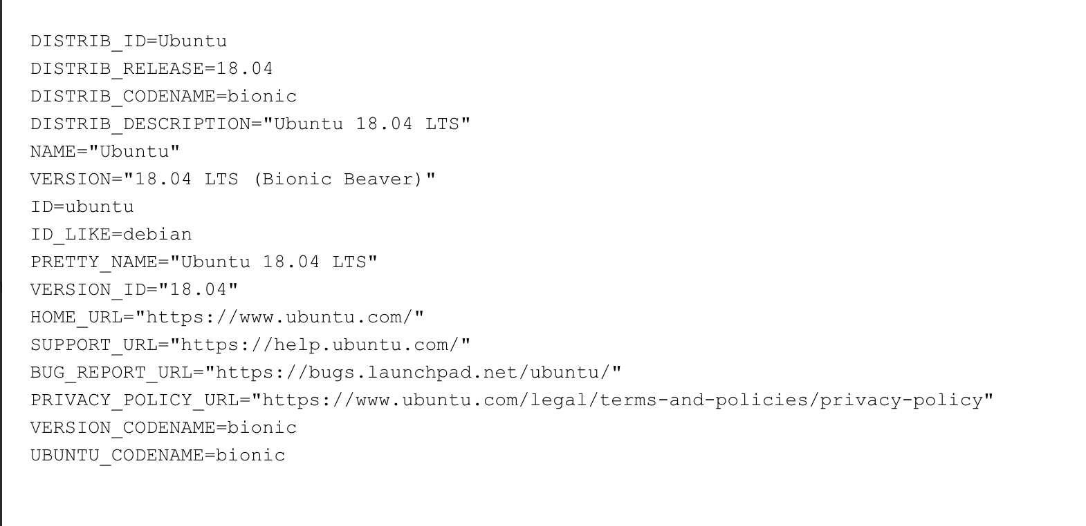

Host OS Information

**Analysis**

Upon running a service version Nmap scan of the target system, we find it is running nginx 1.14.0 which reached its end of support (EOS) on April 19, 2019. 5 years without security patches and updates from the vendor incurs significant risk for the operational security of the site as threat actors can develop exploits freely with no patches to defend against their attacks. Additionally, the server’s OS also appears to be running end-of-life software. Though more recent, Ubuntu 18.04 reached its end-of-life on May 31, 2023. Still, within just 1 year significant vulnerabilities could be identified and exploited with no patches to mitigate them. The business impact is still high since any aspect of cybersecurity (confidentiality, integrity, availability) could be severely affected by outdated software.

**Technical Recommendations**

We strongly advise Bulldog Industries to use the latest version of nginx: 1.26.0 which was released on April 23, 2024. If these legacy systems are absolutely necessary, it is suggested that they be segmented in their own network with limited access to the internal network, preferably in a DMZ. Additionally, upgrading the host OS to Ubuntu 24.04 LTS released in April 2024 to strengthen their security posture.

**Denial of Service Vulnerability**

**Threat Level**

Medium

**Vulnerability**

Medium

**Impact**

High

**Risk Rating**

Medium

**CVE: CVE-2011-3192**

**Proof of Vulnerability**

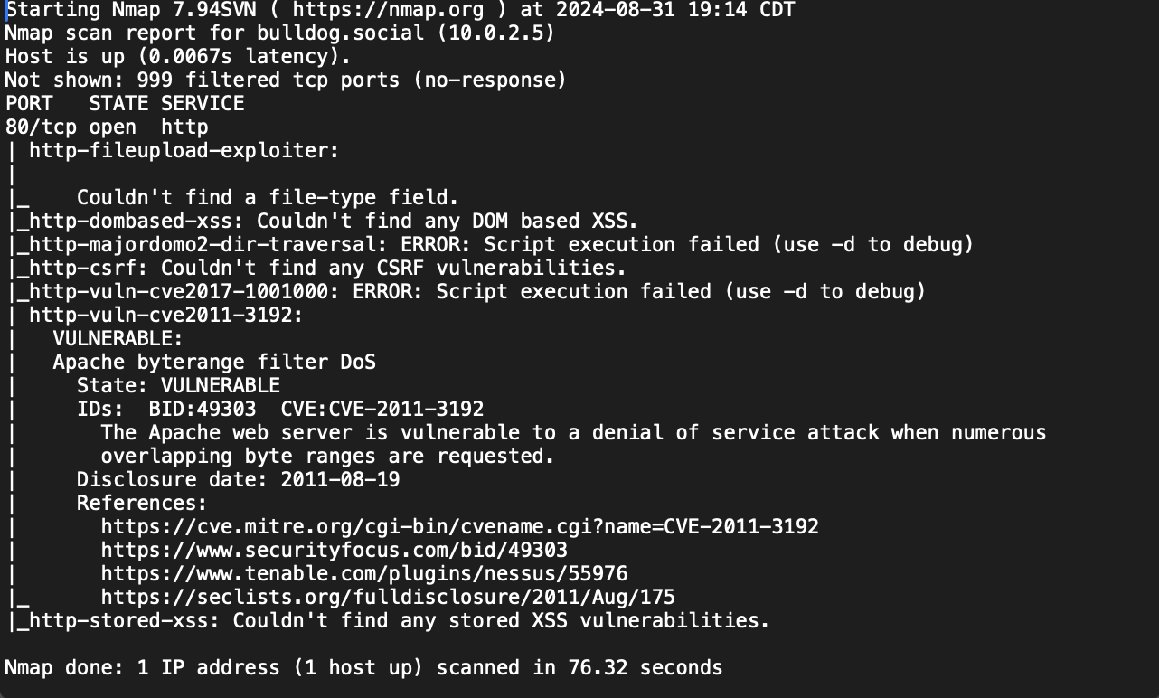

**Analysis**

The byte-range filter in the Apache HTTP Server 1.3.x, 2.0.x through 2.0.64, and 2.2.x through 2.2.19 allows remote attackers to cause a denial of service (memory and CPU consumption) via a Range header that expresses multiple overlapping ranges, as exploited in the wild in August 2011. The business impact is high as this could mean the website’s availability could stop if it were to be attacked through this method.

**Technical Recommendations**

The best solution is to upgrade to a patched version of Apache. Ensure you are using **Apache 2.2.20 or later**, where the vulnerability is fixed. If that can’t be done a preventive control such as a WAF (web-application firewall) should be implemented. Deploying a WAF to filter out malicious requests containing excessive or malformed Range headers would also mitigate this threat down to an acceptable threshold. Cheaper solutions include configuring a rate-limiting mechanism to prevent resource exhaustion attacks. This can limit the impact of an attack by controlling the number of requests per client. Load balancers can also be installed as compensating controls.

# 5. Technical Methodology

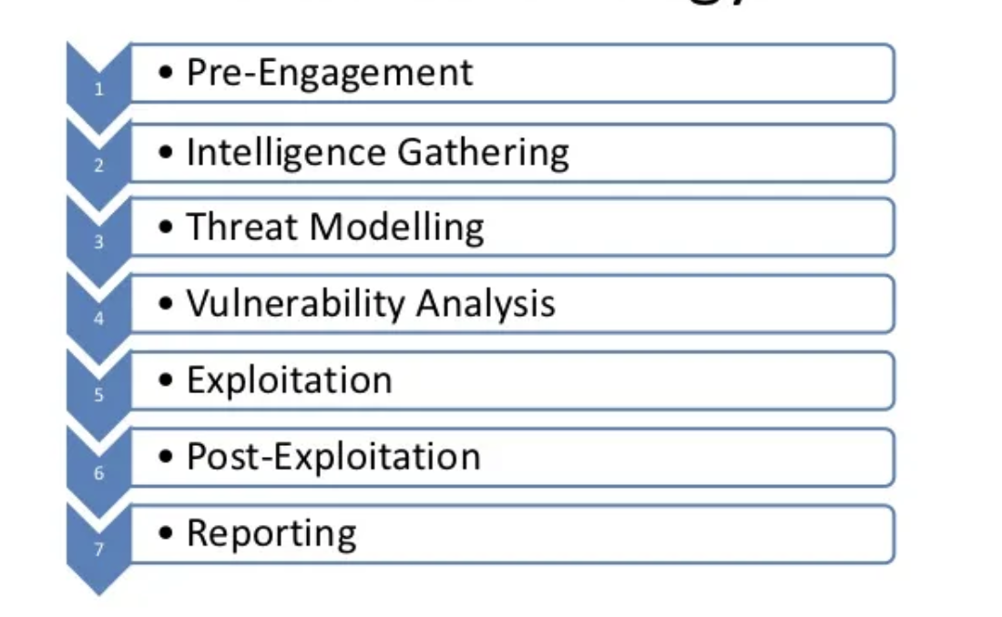

Penetration Testing Execution Standard Full

In this section, we will go on an in-depth technical approach to how the engagement started, progressed, and finished. As mentioned in Section 3, our methodology was centered around the PTES (Penetration Testing Execution Standard). For practical purposes, we can reduce the first four phases of the PTES to a reconnaissance phase.

## 5.1 Reconnaissance

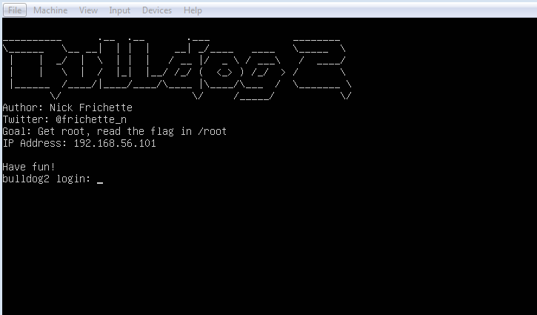

Image of what the vulnhub box looks like

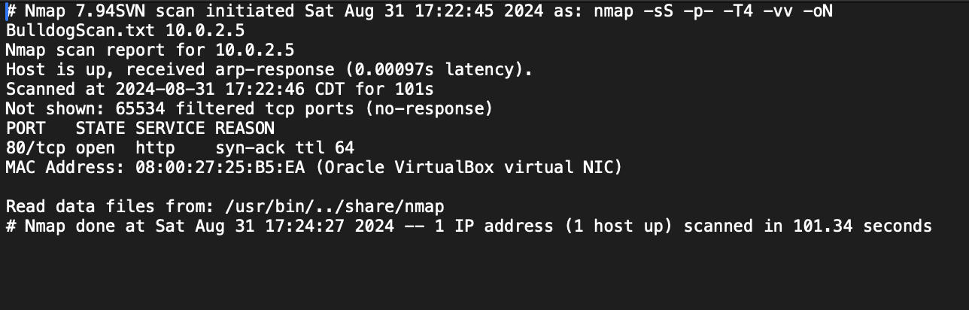

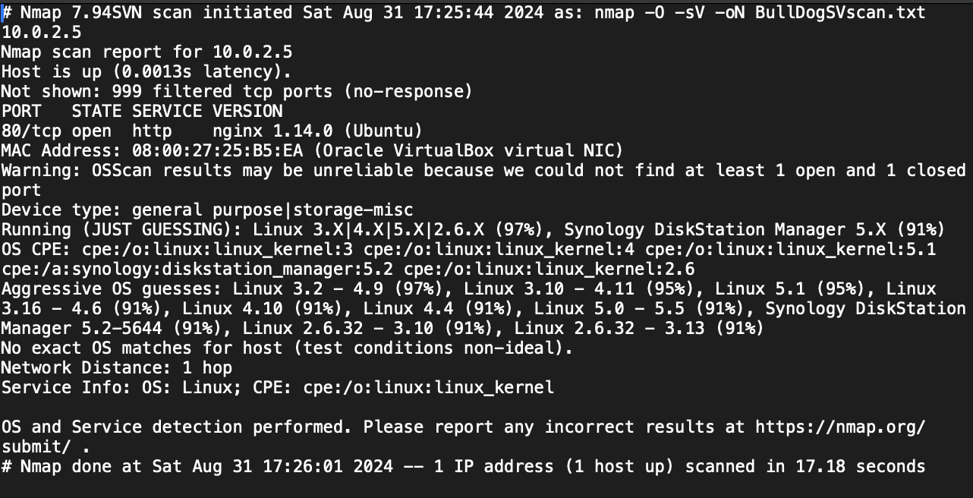

Before even going to the website, I opened up Nmap in my terminal and performed 3 different scans. The first was a stealth scan using syn packets. The results were just one open port, 80 running HTTP. The second was a service version and operating system scan to see what kind of system we could be looking at. The results were the version of HTTP being nginx 1.14.0 and the OS likely being a Linux distribution. The third and final scan was a UDP scan, which yielded no results meaning no UDP ports were found to be open. After our initial Nmap scans, we fire up Firefox and head to the 10.0.2.5 address.

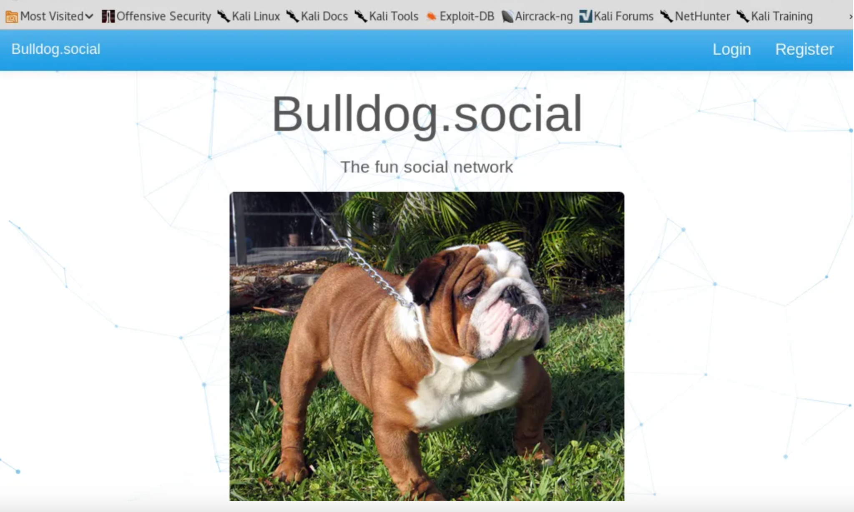

Bulldog.social Home Page

We can see that we have a basic website on this host. We notice a few key items, a login page and a register page. The register pages just tell us that the site is “full” and we can't make an account.

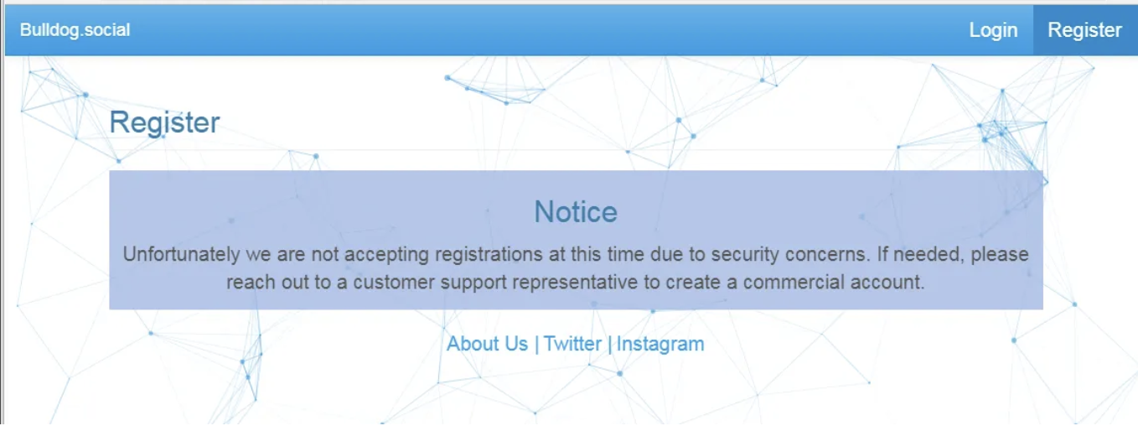

Let's see if the login page is more useful to us.

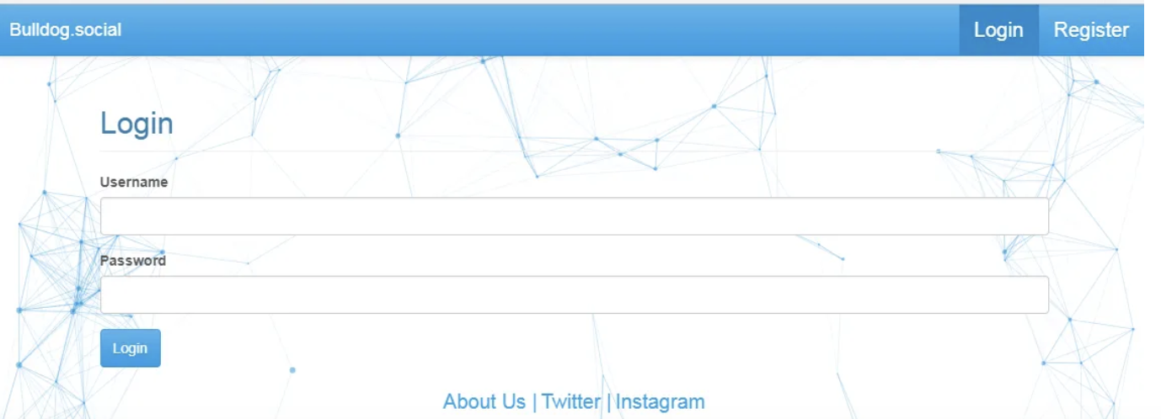

Sweet, we see a login dashboard we can try some stuff out with it. Let's come back to that page later though. For now, we will continue on our enumeration and reconnaissance phase which involves enumerating directories and files for the domain. We can use dirb and dirbuster for this purpose.

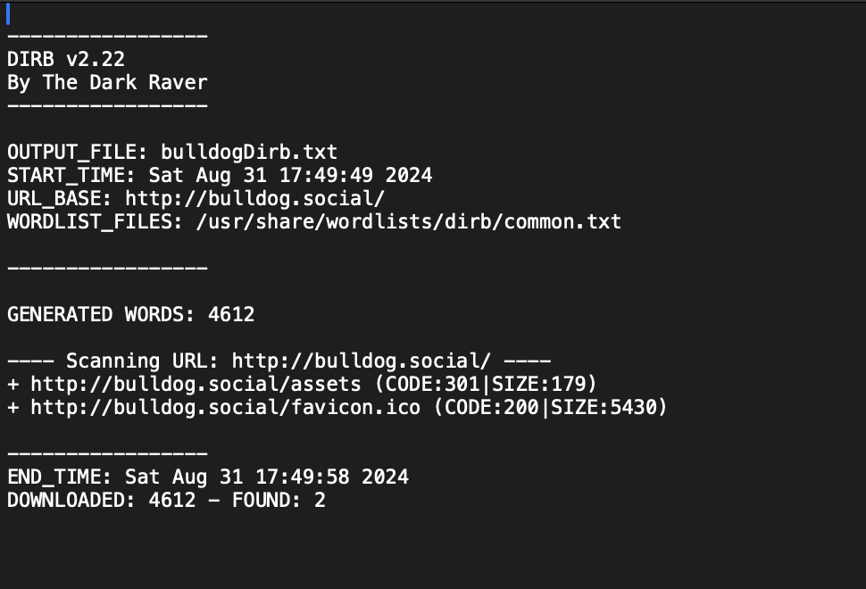

Log of Dirb Scan

Dirbuster pretty much returned the same results. And after exploring the ‘assets’ directory I concluded we weren’t going to progress much via directory traversal. Our enumeration and reconnaissance phase took us as far as we could get. Now let's see what we can do with the information we possess and see if we can start exploiting any vulnerabilities in the site.

## 5.2 Exploitation

Heading back to the login page we can try and start doing some injection attacks and see if any are successful. A few minutes later, I concluded that the user login had some sort of filter, which made it defend against XSS and SQL attacks in the login fields and URL. However, when I was looking at the http requests in BurpSuite I came across a specific field. Anytime I went to the Users directory, the site added a parameter to my request ‘/Users/getUsers?limit=9’.

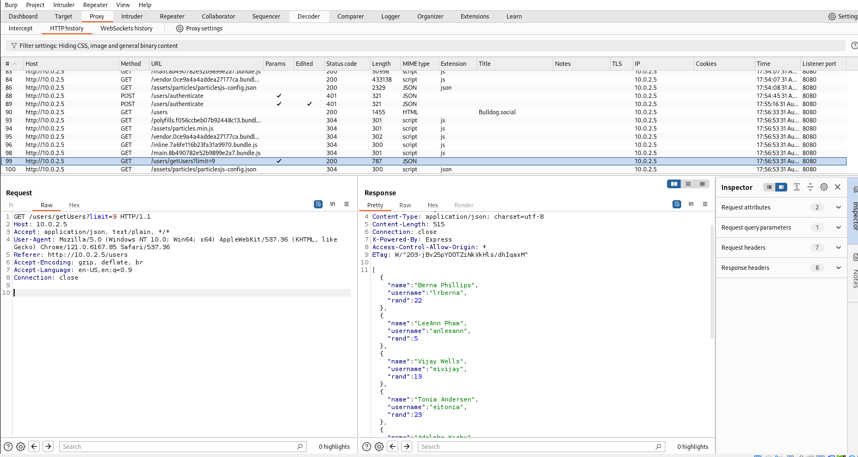

Let's change the default parameter of 9 and just remove it and see what the site returns to us:

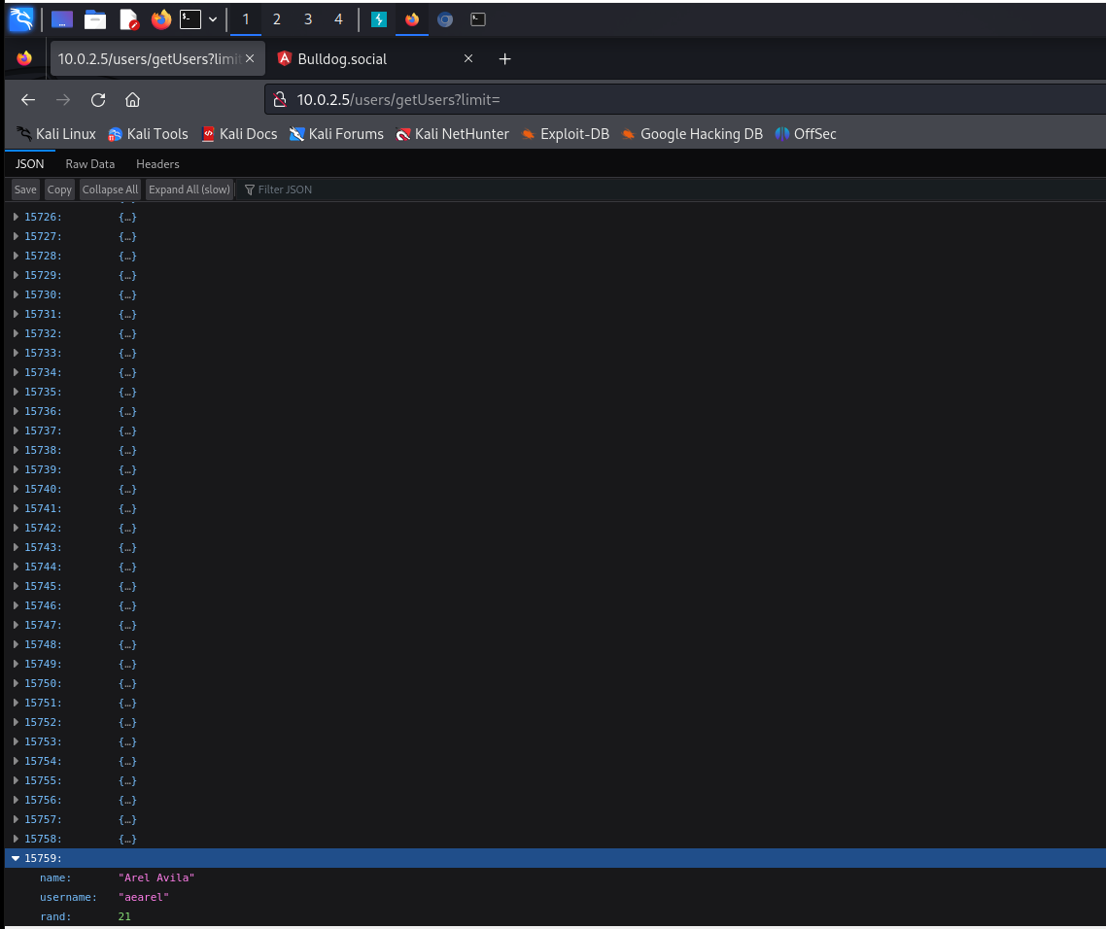

Interesting. We get a list of ALL users with accounts and their usernames. Let’s curl this information into a text file to throw it into a password brute-forcing tool for later.

With some googling and research, we can use this command to extract the usernames into a Txt file

‘curl http://bulldog.social/users/getUsers/ | jq . | grep username | cut -f4 -d”\”” > users

Now we have a list of all the usernames in a file called “users”.

Instead of using Hydra and John the Ripper which are mainly used for cracking network passwords and hashes, we can try a tool called wfuzz which is specifically designed for web app pen-testing.



Within 10 minutes of the tool running and we’ve already obtained someone's credentials. Let’s log in with their credentials and see what we can do with their account.

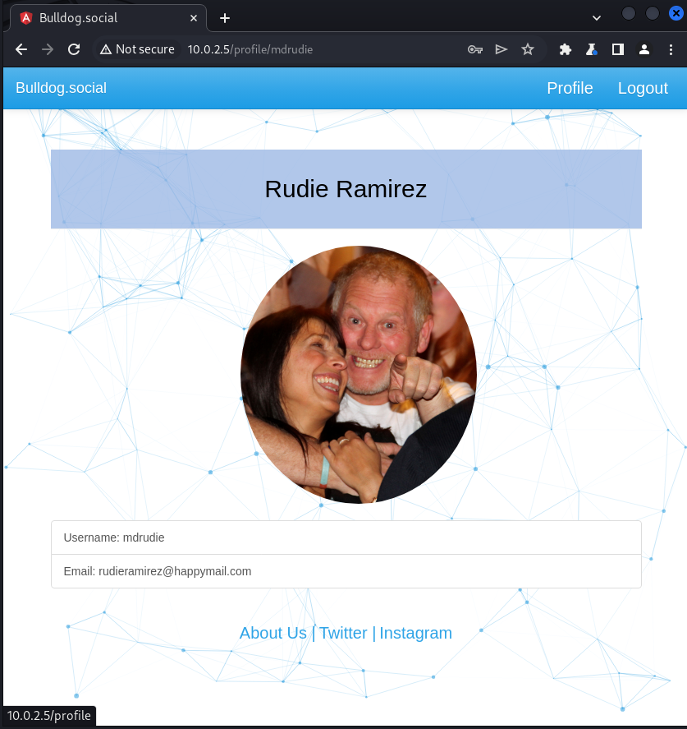

Not much we can do once we’re logged in. Let’s open up web developer tools to take a look at the source code of the site and see if we can find anything. Eventually, we stumble across something interesting:

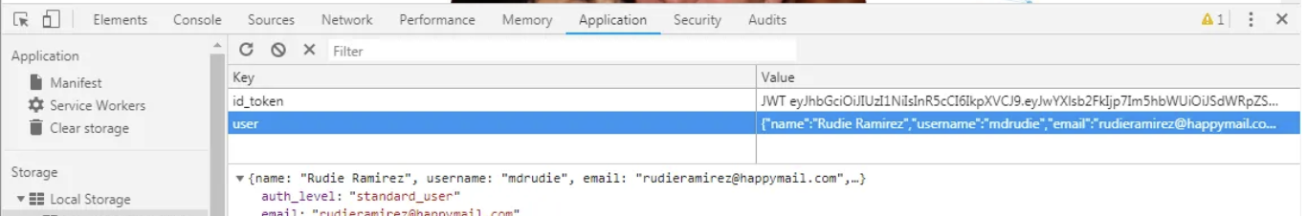

Our “Auth_level” which we can assume means authentication level, is a standard user. Perhaps there is an admin user auth level as well?

Upon digging around the javascript functions we find one that checks for a “master_admin_user”. Now we know the name of the admin auth level. Let’s see if we can change it within our browser.



Great. We can manually change our auth level using the web developer tools. Let’s see what changes occur within our new level of permissions.



We see a new Admin button let's see what's on there.

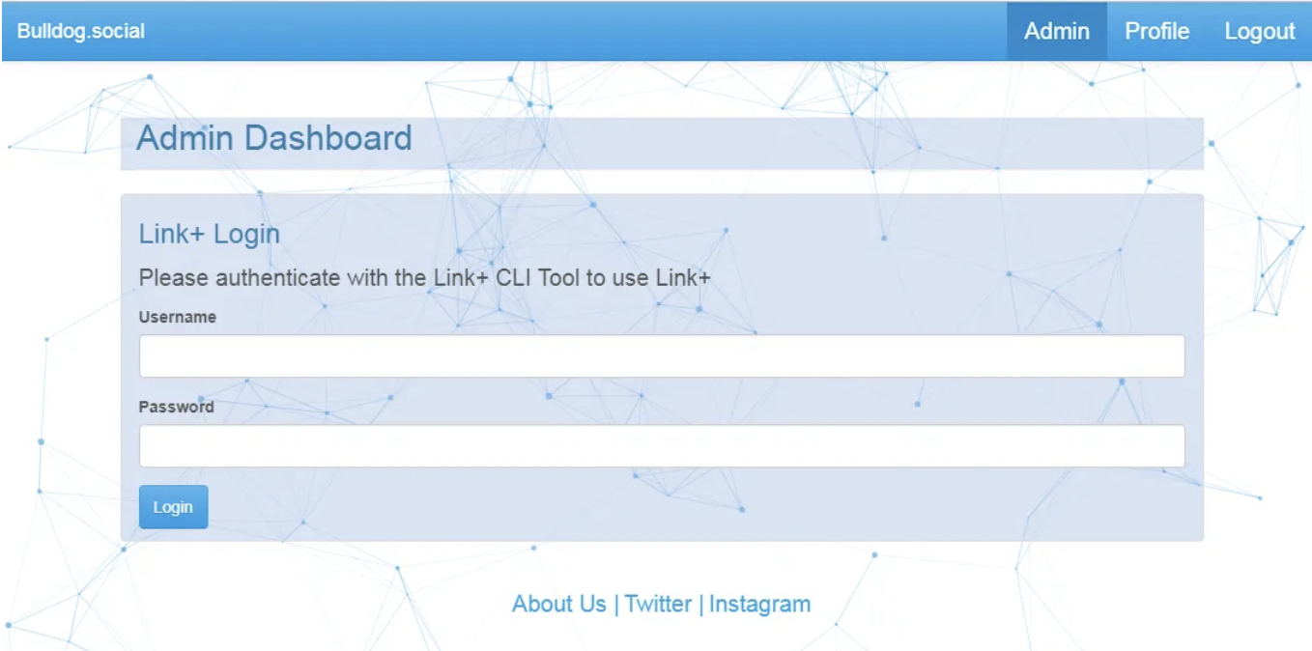

Just like we mentioned in the vulnerability analysis portion of this report, we know the login function is utilizing a CLI for authentication. Because of this, we can attempt to throw in some shell commands and see what the program will throw back at us. We can start with something basic like a ping command and see what we get.



WireShark is open just to verify if we get some ICMP packets, which we do. This confirms that the login is vulnerable to command injection. Now we can focus on how to exploit this vulnerability and get a shell. Doing some googling we find a command we can use to potentially get a reverse shell connection. Since we are going to be expecting a reverse shell connection, netcat will be our weapon of choice in this instance. Having the command in the login field we hit enter and wait to see what we get on our terminal listening with Netcat.



Fantastic, it worked. Now that we have gained command-line access to the server. It’s starting to shift into the post-exploitation phase where can start some privilege escalation and action on our objectives, in which case is to capture the flag.

## 5.3 Post-Exploitation

After a while of poking around on the server, I had done some enumeration and intel gathering about my environment. I enumerated the users on the system by printing the contents of the ‘/etc/passwd/’ file.

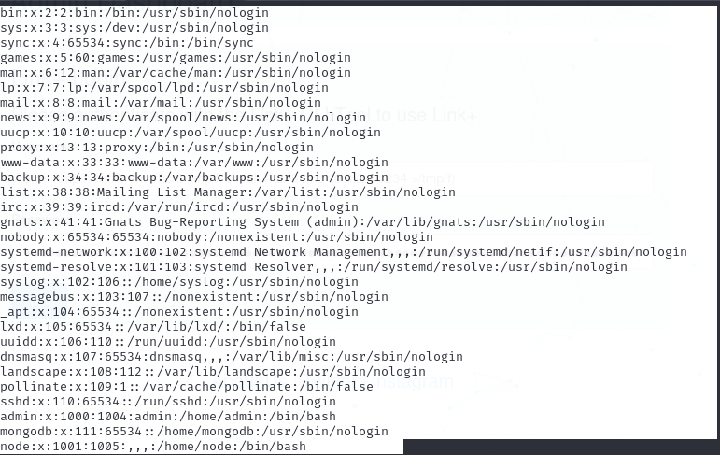

Great we can copy this info and just add it to a txt file we can call BullDogUsers.txt just in case. However, after analyzing the password file, I noticed a huge vulnerability: everyone has full permission to the file.

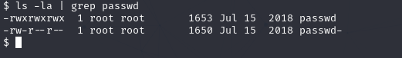

This is especially dangerous as we mentioned before, as anyone can write to this file including adding a new entry with root permissions. Let’s do that for privilege escalation.

First, we need to generate a new hash for the new entry:

We can run

**“perl -le ‘print crypto(“newroot” , ”newroot”)’**

Essentially this creates a hash in which the password will be newroot. The password is the first argument and the salt is the second argument.

This outputs ‘neMlQH0dQoK0k’ as our hash. Now we can open the password file with nano or vim and append the following entry:



From then on we can simple do ‘su newroot’ to switch our user to newroot.

If the reverse shell gives you an error like ‘su must be done on a terminal’

You can run **bash -i -c 'python -c "import pty; pty.spawn(\"/bin/bash\")"'** to get the shell in interactive mode. Now you can do **su newroot** and type in ‘newroot’ as your password and you’re now root.

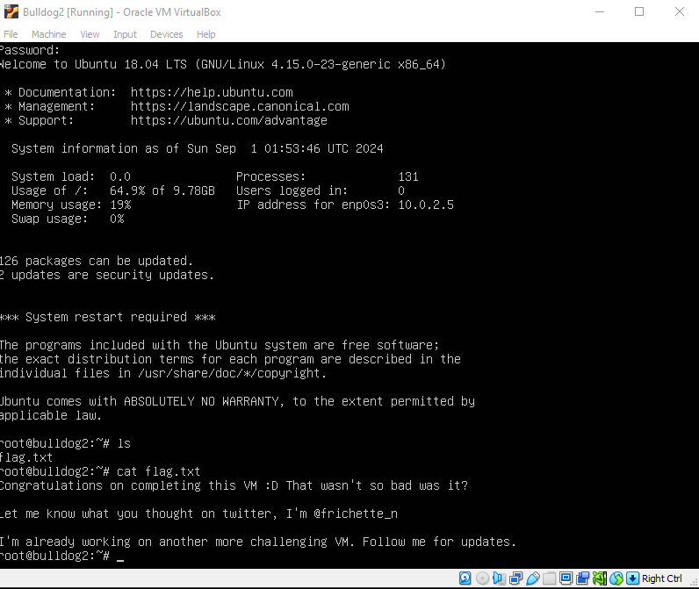

Our last step is to complete our object and capture the flag. Luckily, it was not difficult to find. Simply do an ‘ls’ and cat the flag.txt file and we get a nice message from the creator. We have completed our objective.